# **End to end Setup DB Schema RBAC & DW**

## Overview

Within this Tasty Bytes Introduction Quickstart you will first be learning about the fictitious food truck brand, Tasty Bytes, created by Snowflake.

After learning about the Tasty Bytes Organization, we will complete the process of setting up the Tasty Bytes Foundational Data Model, Workload Specific Roles + Warehouses and all necessary Role Based Access Control (RBAC).

## Who is Tasty Bytes?

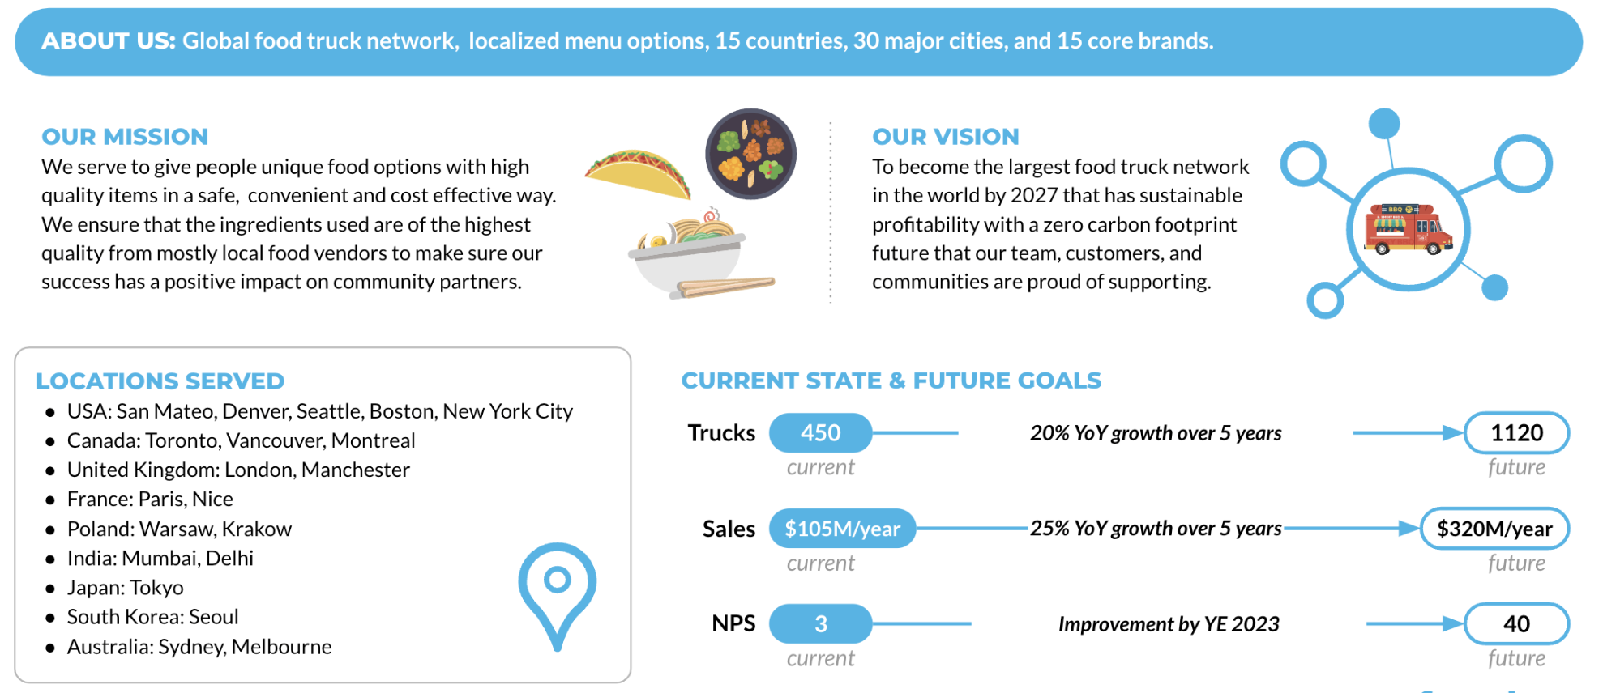

## What You Will Learn

* How to Create a Snowflake Worksheet
* How to Execute All Queries within a Snowflake Worksheet Synchronously
* How to Explore Databases, Schemas, Tables, Roles and Warehouses via SQL in a Snowflake Worksheet

## What You Will Build

* The Tasty Bytes Foundation that empowers you to run Powered by Tasty Bytes - Quickstarts.
  + A Snowflake Database
  + Raw, Harmonized and Analytic Schemas complete with Tables and Views
  + Workload Specific Snowflake Roles and Warehouses
  + Role Based Access Control (RBAC)

## **Setting up Tasty Bytes**

## Overview

For this Quickstart, you will use the Snowflake web interface known as Snowsight. If this is your first time leveraging Snowsight, we highly recommend taking a look at our [Snowsight Documentation](https://docs.snowflake.com/en/user-guide/ui-snowsight) for a high-level walkthrough.

## Step 1 - Accessing Snowflake via URL

* Open a browser window and enter the URL of your Snowflake Account. If you do not already have a Snowflake account please revisit the previous section to sign up for a Free Snowflake Trial Account.

## Step 2 - Logging into Snowflake

* Log into your Snowflake account.

## Step 3 - Navigating to Worksheets

* Click on the Projects Tab in the left-hand navigation bar and click Worksheets.

## Step 4 - Creating a Worksheet

* Within Worksheets, click the "+" button in the top-right corner of Snowsight.

## Step 5 - Renaming a Worksheet

* Rename the Worksheet by clicking on the auto-generated Timestamp name and inputting "Tasty Bytes - Introduction"

## Step 6 - Accessing hosted Setup SQL in GitHub

* Click the button below which will direct you to our Tasty Bytes SQL Setup file that is hosted on GitHub.

[tb_introduction.sql](https://github.com/Snowflake-Labs/sf-samples/blob/main/samples/tasty_bytes/FY25_Zero_To_Snowflake/tb_introduction.sql)

## Step 7 - Copying Setup SQL from GitHub

* Within GitHub navigate to the right side and click "Copy raw contents". This will copy all of the required SQL into your clipboard.

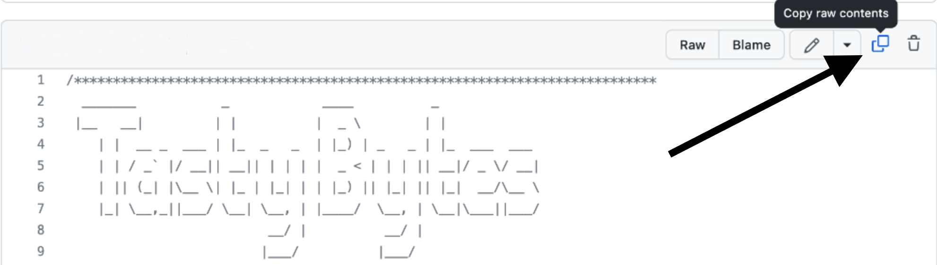

## Step 8 - Pasting Setup SQL from GitHub into your Snowflake Worksheet

* Path back to Snowsight and your newly created Worksheet and Paste (*CMD + V for Mac or CTRL + V for Windows*) what we just copied from GitHub.

## Step 9 - Synchronously Running all Setup SQL

* Click inside the newly created Tasty Bytes - Setup Worksheet, and next to "► Run" Click "▼" and choose "Run All"



## 

## 

## 

## 

## Step 10 - Completing Setup

* After clicking "Run All" you will see queries begin to execute. These queries will run one after another with the entire worksheet taking around 3 minutes. Upon completion you will see a message stating tb_101 setup is now complete .

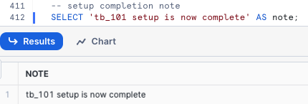

## **Exploring the Tasty Bytes Foundation**

## Overview

## With the Tasty Bytes Setup successful, we can now explore the Database, Roles and Warehouses we created.

## Note: Within the *Tasty Bytes - Setup* worksheet you created in previous section, please scroll to the bottom and Copy, Paste and Run the SQL included in each step below.

## Step 1 - Exploring the Tasty Bytes Database

## This query will return the Database we created via [SHOW DATABASES](https://docs.snowflake.com/en/sql-reference/sql/show-databases.html) using our SYSADMIN role.

## USE ROLE sysadmin;

## SHOW DATABASES LIKE 'tb_101';

## 

## Step 2 - Exploring the Schemas within the Tasty Bytes Database

## This query will return the Schemas within the Database we created via [SHOW SCHEMAS](https://docs.snowflake.com/en/sql-reference/sql/show-schemas).

## SHOW SCHEMAS IN DATABASE tb_101;

## 

## Step 3 - Exploring the Tables within the RAW_POS Schema within the Tasty Bytes Database

## This query will return the Tables within the raw_pos schema via [SHOW TABLES](https://docs.snowflake.com/en/sql-reference/sql/show-tables)

## SHOW TABLES IN SCHEMA tb_101.raw_pos;

## 

## Step 4 - Exploring the Tasty Bytes Roles

## This query will return the Roles we created via [SHOW ROLES](https://docs.snowflake.com/en/sql-reference/sql/show-roles).

## SHOW ROLES LIKE 'tb%';

## 

## Step 5 - Exploring the Tasty Bytes Warehouses

## This query will return the Warehouses we created via [SHOW WAREHOUSES](https://docs.snowflake.com/en/sql-reference/sql/show-warehouses).

## SHOW WAREHOUSES LIKE 'tb%';

## 

## Step 6 - Putting it All Together

## These next three queries will:

## Assume the tb_data_engineer role via [USE ROLE](https://docs.snowflake.com/en/sql-reference/sql/use-role.html)

## Leverage the tb_de_wh Warehouse via [USE WAREHOUSE](https://docs.snowflake.com/en/sql-reference/sql/use-warehouse.html)

## Query our raw_pos.menu table to find which Menu Items are sold at our Plant Palace branded food trucks.

## USE ROLE tb_data_engineer;

## USE WAREHOUSE tb_de_wh;

## 

## SELECT

## m.menu_type_id,

## m.menu_type,

## m.truck_brand_name,

## m.menu_item_name

## FROM tb_101.raw_pos.menu m

## WHERE m.truck_brand_name = 'Plant Palace';

## 

## Amazing! Within a few minutes we now have a Tasty Bytes demo environment complete with data, roles and warehouses set up in our Snowflake account. Let's now take a look at all of the other Tasty Bytes Quickstarts available to us to leverage.